TUTORIAL 3
Making buffers, summing points in a polygon, and calculating distance
Task: To create a variety of geographic variables using points, distance, area and buffers.
Data needed:
- Obesity (BMI > 30) case locations (Auck_ObesityCases.shp – these are not actual data)
- Greenspace for Auckland (Auck_Greenspace.shp)
- Fast food outlets for Auckland (Auck_foodoutlets.shp)
- Optional: Auck_CAUs or use a basemap for reference

1. Open a new session of ArcGIS Pro.
You can open a blank map or start without a template— it does not matter.
Load all the datasets into your current map using “Add data”.
2. Make buffers around greenspaces.
Open the Analysis tab and click on ‘Tools’ to open the ArcToolbox.
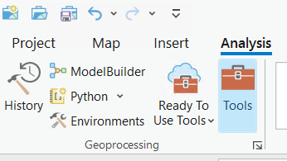

You will see the ArcToolbox pane on the right side. Go to ‘Toolboxes’ ‘Analysis Tools’ ‘Proximity’ ‘Buffer.’
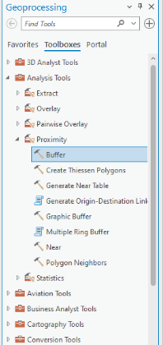
In the dialog box, select your greenspace layer for ‘Input Features.’ In ‘Output Feature Class’, name of your new buffer file as “Auck_GS_200Buffer.shp”. Save your new buffer file to your personal working folder. Enter linear unit of 200 meters in the ‘Distance’ box.
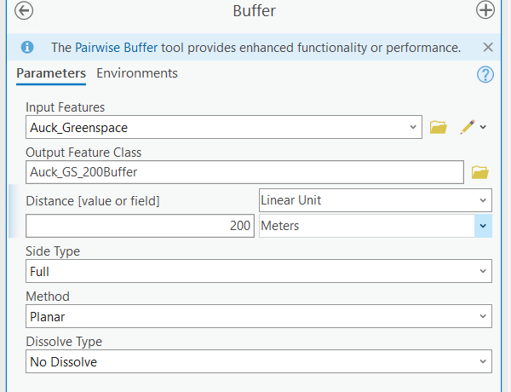
Verify your entries are correct, then click ‘Run’. You will now see new buffers on your map.
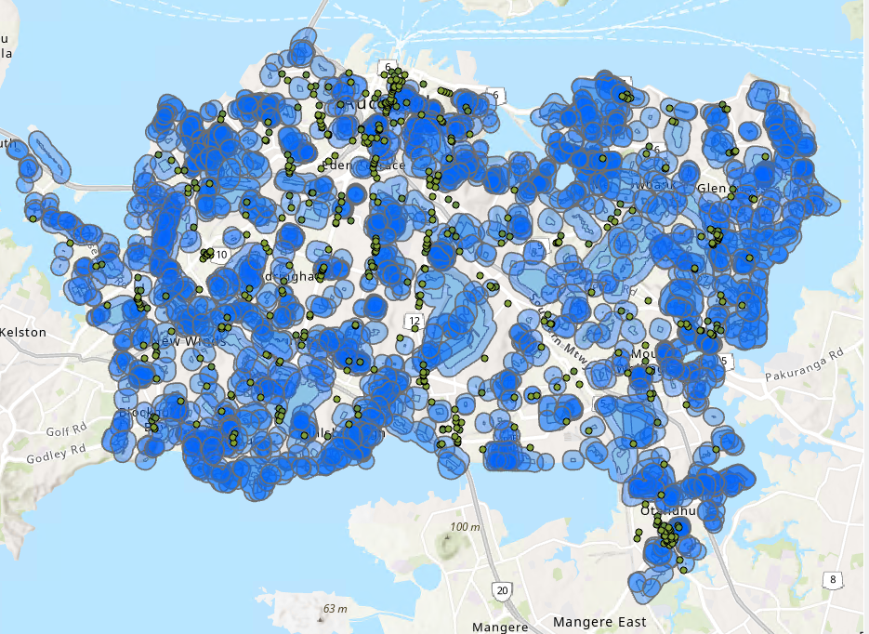
Repeat this once again – but change the buffer size to 500 meters.

Answer the following:
- What might be the significance of using different buffer sizes?

_________________________________________________________

_________________________________________________________

3. Count points within a polygon – how many obesity cases live within 200 metres/500 meters of a greenspace?
Right click on the Auck_GS_200Buffer ‘Joins and Relates’ ‘Add Spatial Join’.
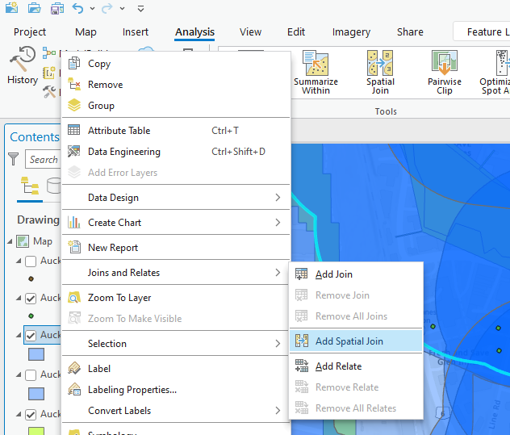
In the ‘Add Spatial Join’ box, add the 200m buffer file as the ‘Target Features’. Choose the “Auck_ObesityCases.shp” file as the ‘Join Features’. Make sure the first option is selected under ‘you are joining points to polygons’ and that their attributes will be summed (check that box). In the ‘Output Feature Class’, name the new file, call it pointpoly.shp, and location. Add to your current map if prompted.
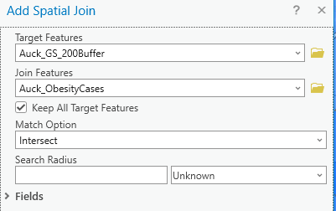

Right click this new file, select ‘Open Attribute Table,’ and find the column ‘join_count’ (some versions may say ‘count’). Highlight column and right click and select ‘Statistics.’ This gives descriptive stats of this attribute field of the number of obesity cases within each 200 meter greenspace buffer.
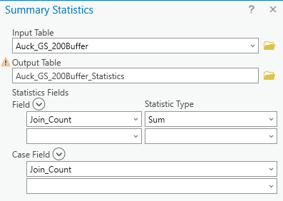
Repeat the above steps for the 500 meter buffer.

Answer the following:
- For any given park (greenspace), what it the highest number of obesity cases within 200 meters, 500 meters

Within 200m _____________________________________________

Within 500m _____________________________________________

4. Distance from obesity case home location to nearest fast-food outlet.
Go to ‘Analysis Tools’ ‘Proximity’ ‘Near’
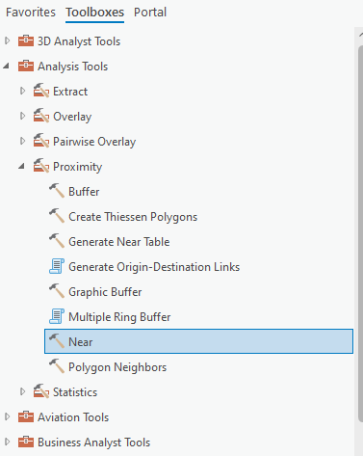
Input feature: “Auck_ObesityCases”. For ‘Near Features’, select “Auck_foodoutlets”. Click ‘Run.’
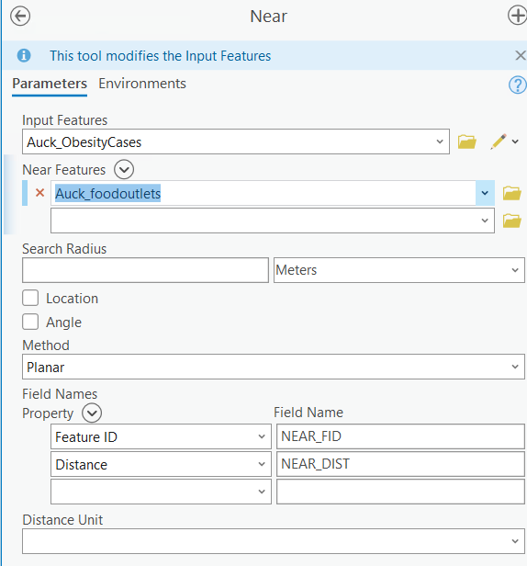
Now look at the attribute table for the obesity case shapefile. Note there is a new column (at the end) that provides distance to the nearest fast-food outlet for each obesity case (called NEAR_DIST).

Answer the following:
- How close is the nearest food outlet, of all the obesity cases? How far is the greatest distance?

Nearest _______________________________

Farthest _______________________________

- Why would a health researcher be interested in knowing this information? Would this be an exposure or an outcome and why (provide a scenario)?

TUTORIAL 3 – BONUS MATERIAL
Protecting sensitive data - Jittering points and display options
Task: To make a map of confidential individual-level, sensitive data by jittering or geomasking points. Then, to adjust display options.
Data needed:
- Obesity case points - Auck_ObesityCases
- Basemaps within ArcMap

1. Export obesity case shapefile as a new shapefile (so that you do not accidentally jitter the real file).
Make sure you have the Auck_ObesityCases shapefile in your current ArcMap session. Then, highlight the file in the Contents pane. Right click.
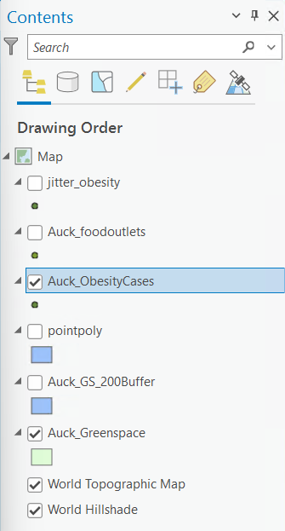
Select ‘Data’ ‘Export Features’. An Export Features window will open. Then, choose a save location (your personal working folder) and a name for this new shapefile. Perhaps select a name such as “jitter_obesity.shp.” After you do this, you will be asked if you want to add the new shapefile to your map – select “Yes”.
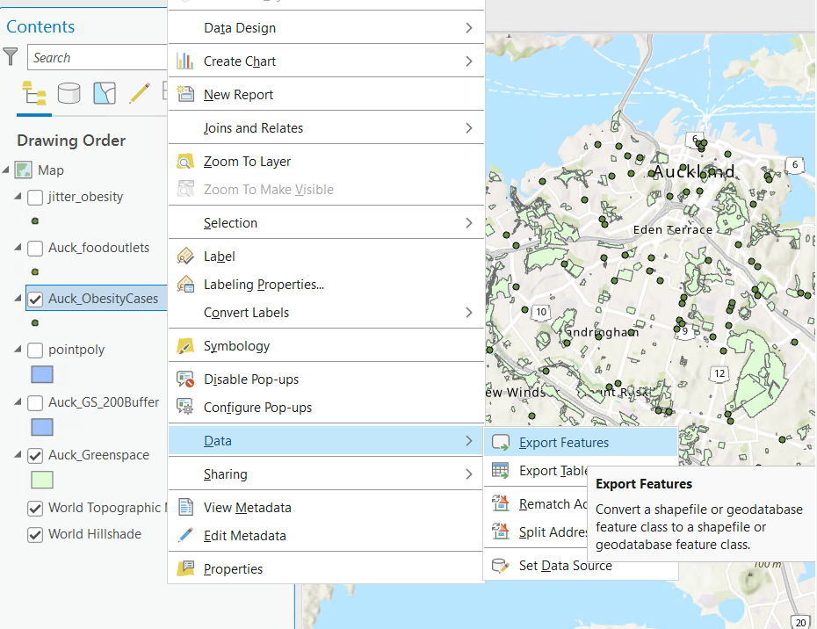
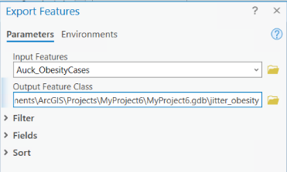
2. Jitter the points.
There are many ways to geo-mask point locations. We are learning a simple method which randomly moves points at a maximum distance using a python script. First, open the Attribute Table of your new shapefile, by highlighting the shapefile name in the Contents pane, right click ‘Open Attribute Table.’
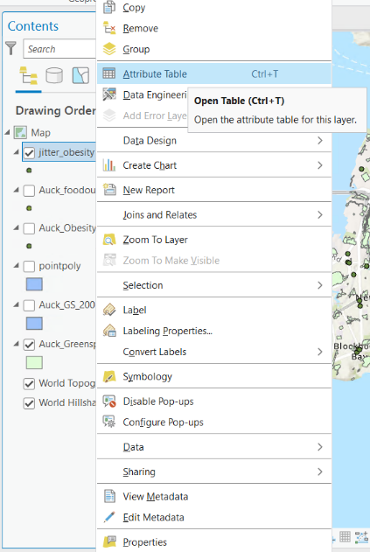
Right click on the ‘Shape’ field and select ‘Calculate Field’. A ‘Calculate Field’ box will appear.
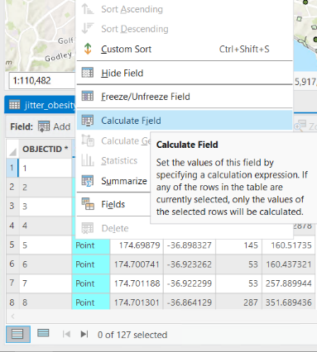
The Expression Type should already be set to ‘Python 3’, and the Code Block text box will be visible. Copy and paste the code from the file “Jitter_Code.txt” (also shown below) into the Code Block text box.
from random import randint,choice

def RandMove(old_pnt,min_shift,max_shift):
neg = [-1,1]

#get the first point from the geometry object
old_x = old_pnt.firstPoint.x
old_y = old_pnt.firstPoint.y

#calculate new coordinates
new_x = old_x + (choice(neg) * randint(min_shift,max_shift))
new_y = old_y + (choice(neg) * randint(min_shift,max_shift))

#create a new point object and geometry to return
new_pnt = arcpy.Point(new_x,new_y)
pt = arcpy.PointGeometry(new_pnt)

return pt

Also, type the following code:
RandMove(!Shape!, 100, 200)
into the ‘Shape =’ box, as shown below:

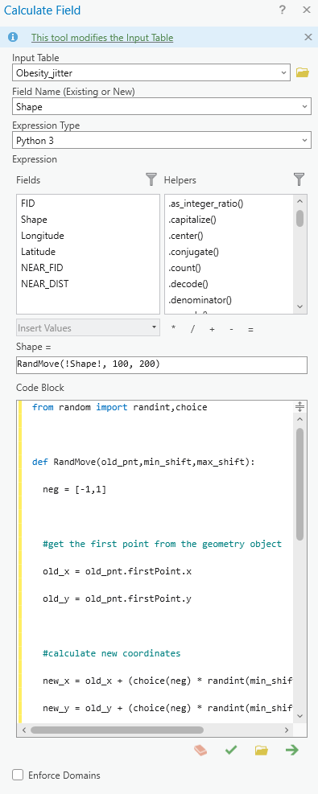
Click ‘Apply’ then ‘Ok’.
Now you should have a jittered point file. (Always check that points did not fall in the water, etc – if so, you would need to individually edit any errors – not covered here).

3. Practice your cartography skills – change display options.
To make this map, you will want to remove, or turn off the display for the original or actual obesity case locations – use the jittered locations only for map creation! You can ensure only the jittered locations are visible in your map view by only checking the “jitter_obesity” layer.
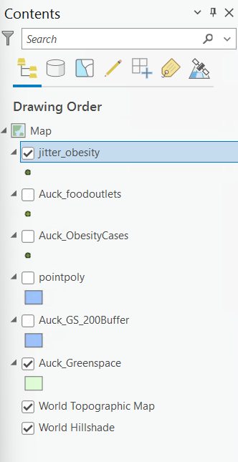
Remember, use only the actual locations for any geographic calculations. Jittered points are only to be used in maps for display.
Change the symbology of the jittered obesity points: Right click the “jitter_obesity” layer in the Contents pane. Select ‘Symbology’.
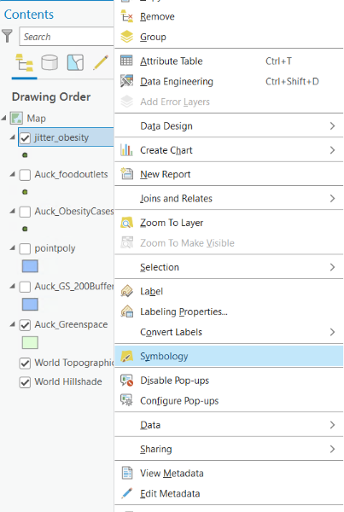
Change the default shape, perhaps to a perfect circle by clicking on the icon in the symbology tab, change the size and color of the point by going to the properties tab within symbology. Click ‘OK’ and close the Symbology tab when you are done.
Change the basemap: In your toolbar, go to the ‘Map’ tab, in the layer section click on Basemap, a drop-down menu appears. Select a basemap that appeals to you and seems appropriate for the purpose of this particular map.
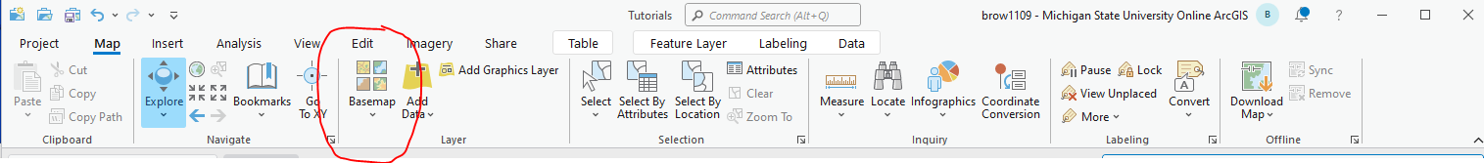
Add title: Create a new layout by going to the ‘Insert’ tab and using the “New Layout” button. Select your preferred layout. Using the skills from Tutorial 1 give your map appropriate elements (e.g., title, north arrow, scale bar, legend). In the dialog box, choose a relevant title for your map (such as “Approximate Obesity Case Locations in Auckland”). You can move the title by clicking and dragging. You can edit the title features by double clicking on the title. Select ‘Change symbol’ and edit the size, color, and font style.
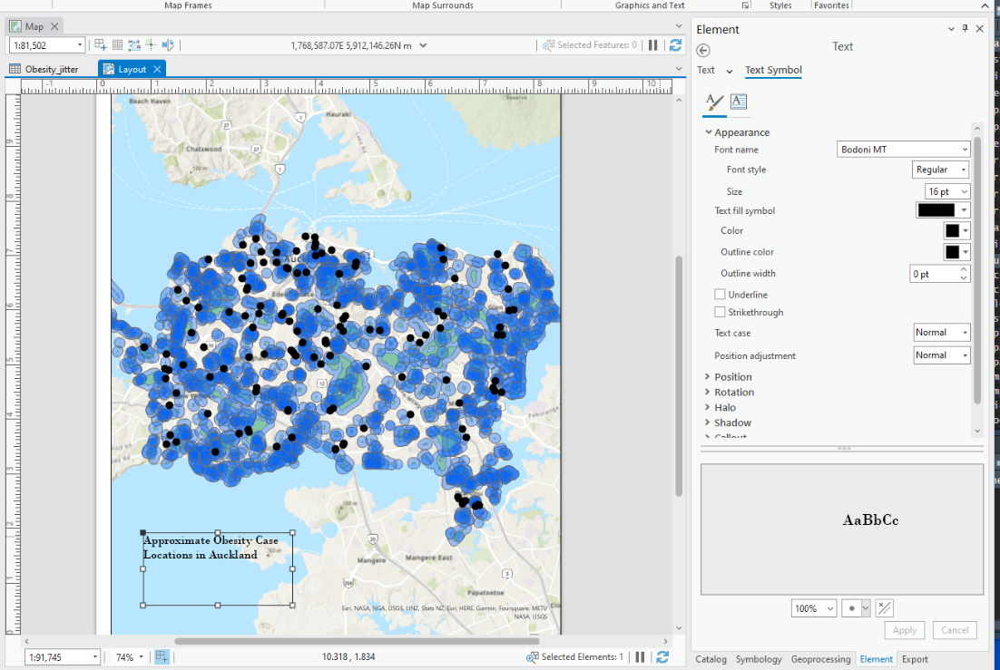

4. Export your final map (in jpeg or tiff format).
Go to ‘Share’ and select ‘Export Map.’ Jpeg files are more compressed than tiff. However, some journals require tiff format for figures. Many journals have requirements about the minimum dots per inch (dpi). Typically, the minimum is 300 dpi. You can set all these parameters on your exported map.
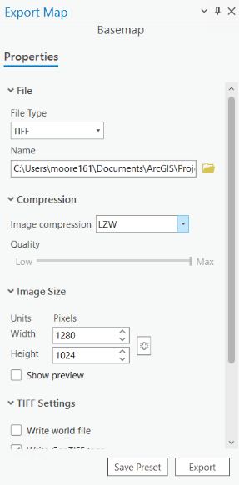
Name the image, select a save location (your personal working folder). Click ‘Export’ to save your map.
*****Remember never to use jittered locations to make geographic calculations!****
TUTORIAL 4
Kernel density mapping
Task: To create a raster map of kernel densities, using a point file of gambling outlet data.
Data needed:
- All gambling outlets in Auckland (Auck_Gambling.shp)

- Load data into new session. Get an idea of how close/far apart the locations are.
Add the gambling outlet shapefile (Auck_Gambling.shp) to a new map project. Note that these are all gambling outlets in this region. For each point, you will determine the distance to the nearest other case.
Go to: ‘Analysis’ ‘Tools’ ‘Proximity’ ‘Near.’
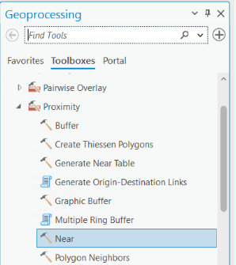
In the dialog box, both the Input Features and Near features are the “Auck_Gambling” outlets. You can set the units to meters if it is not set automatically. When are you all set, click ‘Run.’
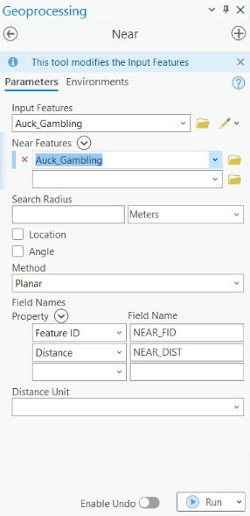
After this runs, open your Attribute Table and look at the two new columns on the right.

Sort the new NEAR_DIST column. Analyze the statistics. To display a histogram right click on the new column (‘NEAR_DIST’) and click statistics.
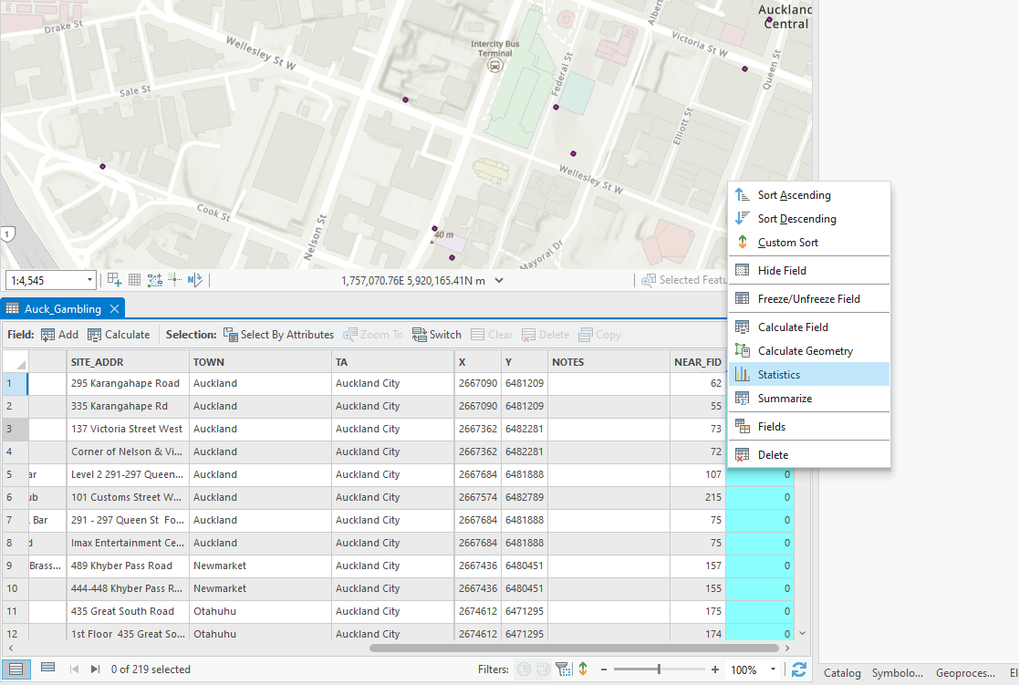
Answer the following:
- How close is the nearest gambling outlet to another one? How far is the greatest distance between outlets? (Hint: sort the new distance column)

Nearest _______________________________

Farthest _______________________________

- Is the distribution normal? Is there a positive or negative skew?

2. Create a kernel density map. After considering the results from calculating the nearest feature, go back to the ArcToolbox in the Geoprocessing pane on the right side of your screen. Navigate to ‘Spatial Analyst Tools’ ‘Density’ and click on the ‘Kernel Density’ tool. We will be running this twice.

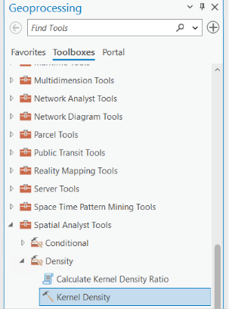
Select “Auck_Gambling” for your input point/polyline feature.
For the first run of this tool, do not set any ‘Population field.’ Select a save location for your new raster file (your personal working folder) and a name for the file. Set the ‘Output cell size’ to 50m. Leave ‘Search radius’ blank (which allows for searching of the entire study area).
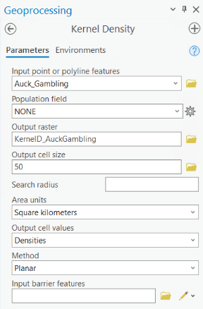
When you are all set, click ‘Run’.
3. Re-run kernel density map. Now it is time to go back to the results from the nearest feature calculation. The larger the search radius, the coarser the densities; the smaller the search radius, the finer the densities. In other words, subtler patterning is detectable with a smaller search radius. In all cases, the densities that result are an artefact or function of the size of the search radius.
There is no hard and fast rule for determining the appropriate search radius and the value may be different depending on the analysis. At some level, it makes little sense to generate densities that are composed of a single entity.
Here, we will use the nearest feature results to set the search radius. Recall we had a large positive skew. Thus, we had a smaller mean than the standard deviation. Set the ‘Search radius’ to half of the maximum distance (maximum/2 = 1474/2 = 737m). Run the kernel density again using this new search radius but keeping all other items the same. Save the output raster using a new name (for example, “gambdensity_737m”).
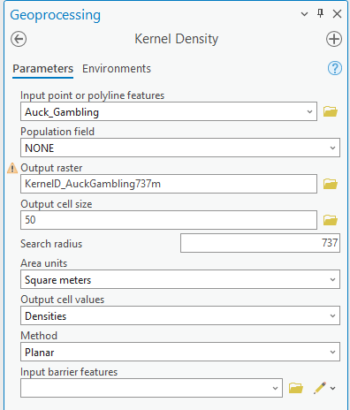

Answer the following questions:
- Were some outliers eliminated? What is the difference between the two raster datasets? Which might be most appropriate? Why?
______________________________________

- Across both raster datasets, are there notable areas of high density? Low density?
______________________________________

- What could these raster datasets be used for in health research?
4. Run the density tool again.
Use the following parameters: cell size 50m, search radius blank, population field = ‘Machines.’ Here, Machines are the number of gambling machines within the outlet. Say that we believe that using machines affect other risky, health-related behaviours differently than gambling by other media (cards, person-to-person games, dice).
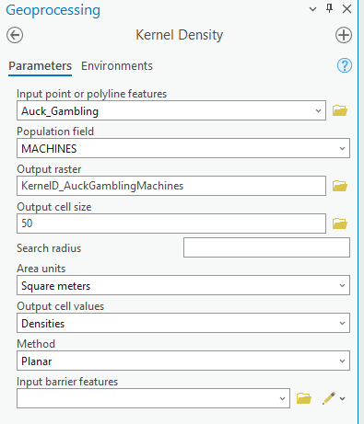
Answer the following question:
- How is the kernel density result different when we use data on the number of machines?
______________________________________

TUTORIAL 5
Spatial autocorrelation

Task: To test for spatial autocorrelation and clustering of crime data.

Data needed:
- Alcohol outlets (Alcohol.shp)
- Crime rates (Crime.shp)

1. Load data into a new session.
You will first examine the data generally to determine if there appears to be spatial autocorrelation in the distribution of crime rates. Then, you will run local statistics to see where clusters exist.

2. Run a spatial autocorrelation test (Global Moran’s I). We are looking for a general pattern of features being clustered or dispersed (as opposed to clustering specifically of high or low values or at specific locations).
Go to ArcToolbox and select ‘Spatial Statistics Tools’ > ‘Analyzing Patterns’ > ‘Spatial Autocorrelation (Global Morans I).’
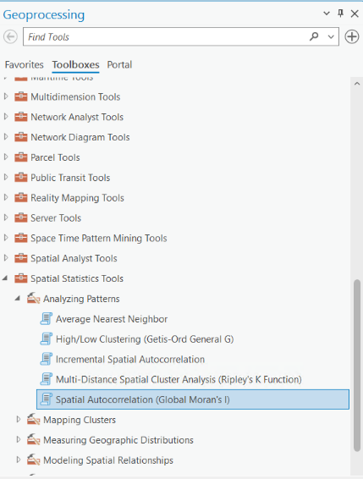
Set your Input Feature Class as “Crime.shp” and the Input field as “AvgAllCrim”. Use the default option for all other settings and leave the ‘Distance Band or Threshold Distance’ box blank. Check the box for ‘Generate Report.’ Click ‘Run.’ Then “View Details”
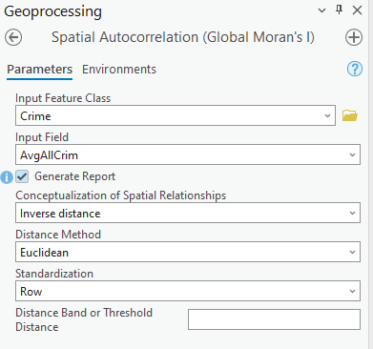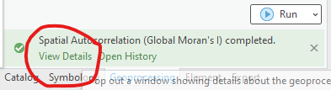
Once the test has finished running, expand the Spatial Autocorrelation category under Current Session in the results window and double click on the report, MoransI_ResultsX.html.
IF YOU CANNOT FIND THE REPORT IN THE CONTENT PLANE, you can locate the default location on the C (or other) Drive where this was stored.
IF THE FUNCTION APPEARS TO HAVE FAILED, open the Results tab. Open the Messages. Sometimes ArcPRO runs but gives an error or warning message. You may have the results in this tab.
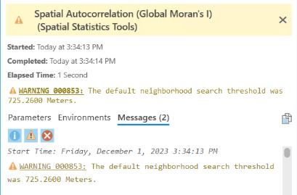
Note: You will need to carefully consider the following: does my study area include both urban and rural areas? Islands? What is the spatial extent of the study area? How should I define a ‘neighbor’ or ‘nearby areas’?

Answer the following:
- What are the results? How do you interpret these results? What are your conclusions?
_____________________________________________

3. Create spatial weights.
You will now create a spatial weights matrix using ‘Spatial Statistics Tools’ > ‘Modeling Spatial Relationships’ > ‘Generate Spatial Weights Matrix.’

Input feature: Crime.shp
Unique ID Field: ID
Output Spatial Weights Matrix file: put this on your personal working folder and name it “weights”
Conceptualization of Spatial Relationships: K_NEAREST_NEIGHBORS
Number of Neighbors: 8.
Click ‘Run’. Then ‘View Details’
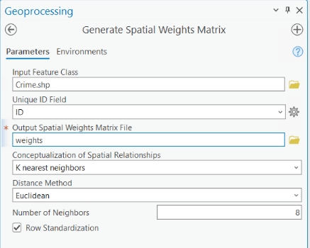
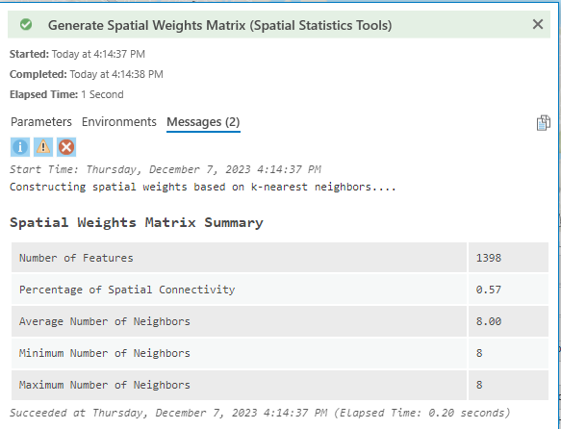
*Note that if you are working across rural and urban areas, usage of this Nearest k-neighbors methods is useful since your polygons (e.g., Census units) will be of very different sizes. The polygons will be small in areas where the population density is high and larger in areas where the population density is low. Therefore, it is useful to define neighbors based on a number rather than a distance.
4. Re-run Global Moran’s I using spatial weights.
Use the same inputs as previously, except change the ‘Conceptualization of Spatial Relationships’ field to ‘GET_SPATIAL_WEIGHTS_FROM_FILE.’
For the ‘Weights Matrix File’ box, select the file on your personal working folder called “weights”.
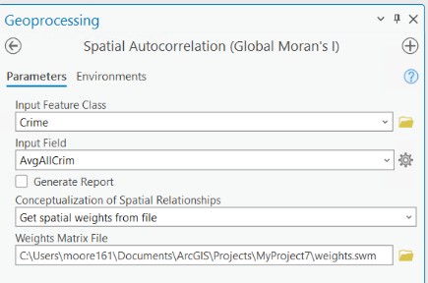

5. Look over the results in the tab (or html file).

Answer the following:
- Did the analysis using k-nearest neighbors change your conclusions?
_________________________________________

6. Calculate Anselin Local Moran’s I to detect specific clusters or outliers.

Go to ‘Spatial Statistics Tools’ ‘Mapping Clusters’ ‘Cluster and Outlier Analysis (Anselin Local Morans I)’
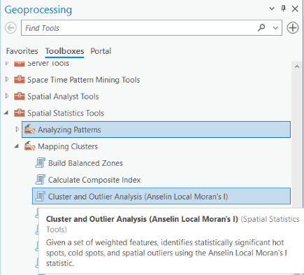

Again, your Input Feature class will be “Crime.shp”. The Input Field is “AvgAllCrim”. Output Feature Class: put this on your personal working folder and name it “Anselin”.
Leave all of the default remaining options. Click ‘Run.’
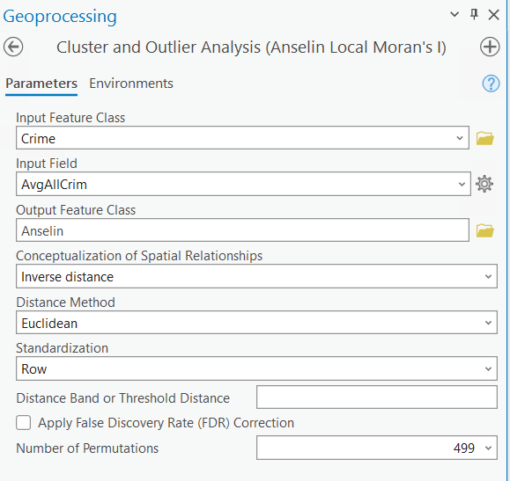

7. Look over the output.
This creates a new feature with the following new fields in the attribute table:
- Local Moran's I index (LMiIndex)
- z-score (LMiZScore)
- p-value (LMiPValue)
- cluster/outlier type (COType)

The z-scores and p-values are measures of statistical significance which tell you whether or not to reject the null hypothesis, feature by feature. In effect, they indicate whether the apparent similarity (a spatial clustering of either high or low values) or dissimilarity (a spatial outlier) is more pronounced than one would expect in a random distribution.

- High-High Cluster = these are meshblocks (MBs) surrounded by MBs with high crime values and their values are still significantly higher than their neighbors.
- Low-Low Cluster = these are MBs surrounded by MBs with low crime values and their values are still significantly lower than their neighbors.
- High-Low Outlier = crime rates are high in these MBs and it is surrounded by low rates
- Low-High Outlier = crime rates are low in these MBs and it is surrounded by high rates
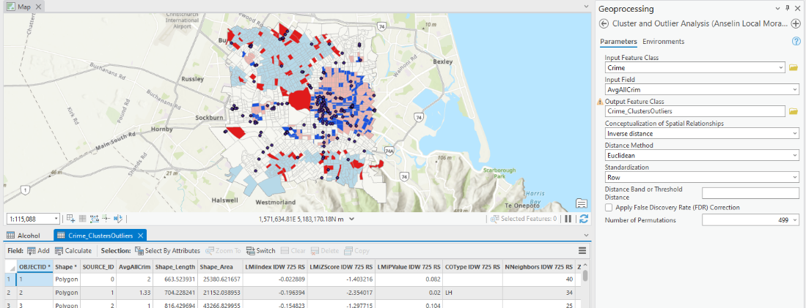

Answer the following:
- Are there any significant clusters present?

- Are there any significant outliers present?

8. Add off-license alcohol outlets to your map.

Answer the following:
- Do you see any patterns that might be worth exploring in more detail?

- Can you think of three possible next steps or limitations in terms of answering your original research question?

