TUTORIAL 1
Adding data, changing symbology, and exporting a map
Task: To create a jpeg or tiff image (map) of Auckland CAUs, using colours to indicate
differing area sizes (km²).
Data needed:
- Auckland CAUs (Auck_CAU_polygons.shp)
1. Open ArcGIS Pro
Go to Programs > ArcGIS > ArcGIS Pro.
Under “New Project”, click “Map”. Name your new project and where you want to save it, then click OK. This will open a blank map.
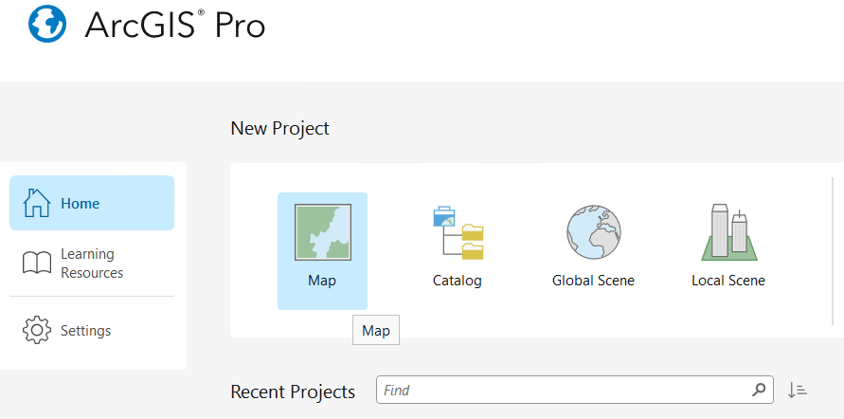
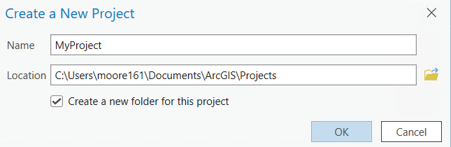
2. Add data to this session.
On the top ribbon, click on the Map tab, then click “Add Data”.
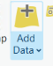
Navigate to your preferred working folder which contains the data for this course.
Select Auck_CAU_polygons.shp.
Click ‘OK’.
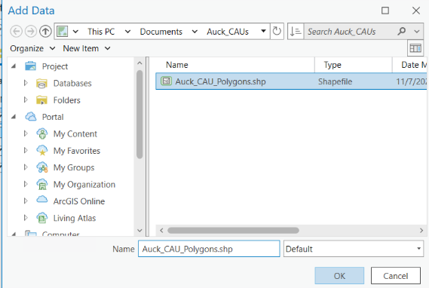
*NOTE: ArcPro automatically includes a basemap of roads, waterbodies, etc. You do not have to use this default setting. Next to “Add Data” is “Basemap” – you can change the basemap here.
*NOTE: You also have a SA1 2023 shapefile in the course folder – it includes boundaries over the water – not great for display.

3. Look at the Attribute Table.
Highlight the CAU shapefile name in the Contents window (left panel). Right click on the CAU shapefile and select “Attribute Table” to open the attribute table in the bottom panel.
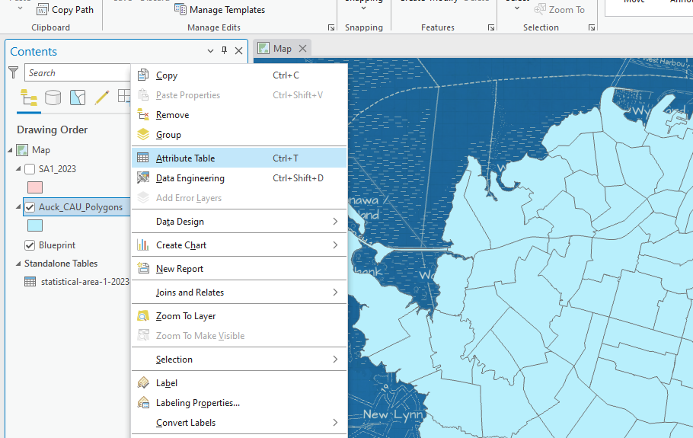
Now you can see the tabular data behind the map image data. Each row represents one geographic unit. In this case, each row is one CAU in Auckland.

Attribute Table should look similar to this:
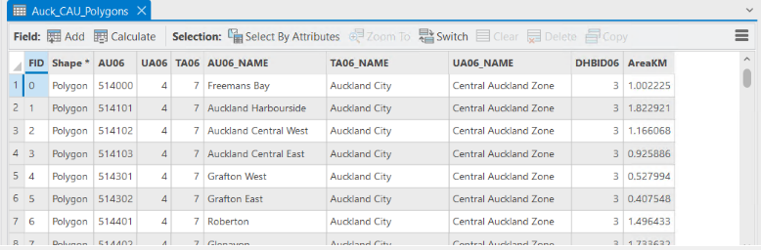

Highlight any row in the table. In the Map window, you can now see that the CAU you highlighted is now highlighted in bold blue. 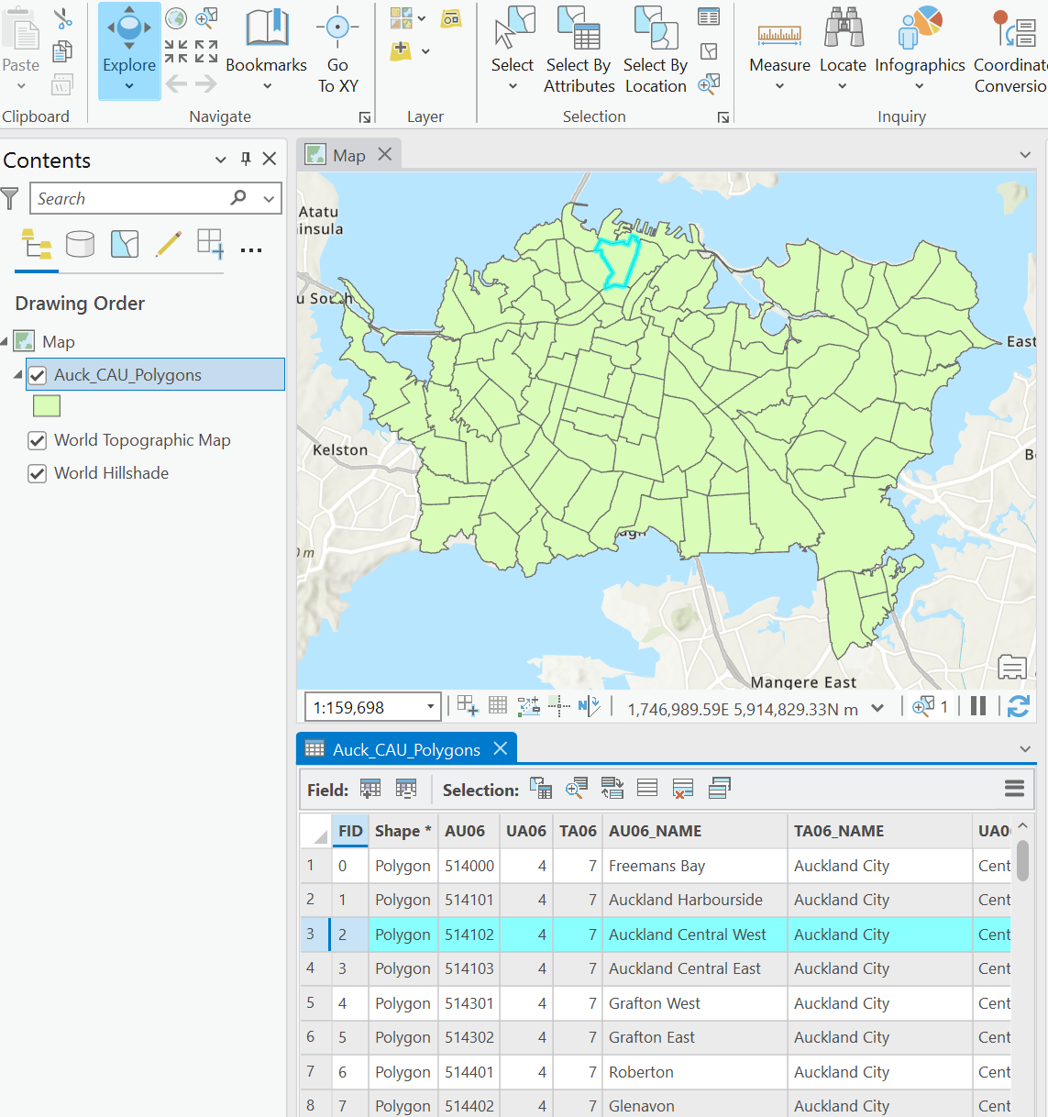
NOTE: If you have difficulty viewing all the CAUs, put your curser over the map and scroll in and out using the mouse. You can also right-click the CAU shapefile in the Contents window and click “Zoom to Layer”.
Clear your selection by clicking “Clear” in the bar above the Attribute Table.
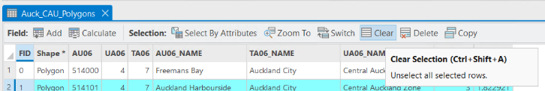

Answer the following: What is the largest area of all the CAUs (km²)?

_______________________________________

Close the attribute table by clicking the X symbol on the “Auck_CAU_Polygons” tab in the Attribute Table window.
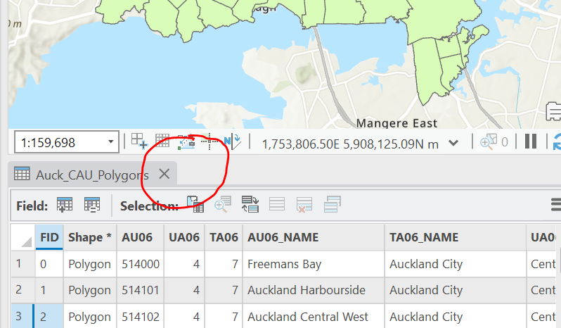

4. Change the appearance of your map.
When you add data, default symbols are applied each time, which you can modify. Right click the CAU shapefile name in the Contents window. Select “Symbology”.
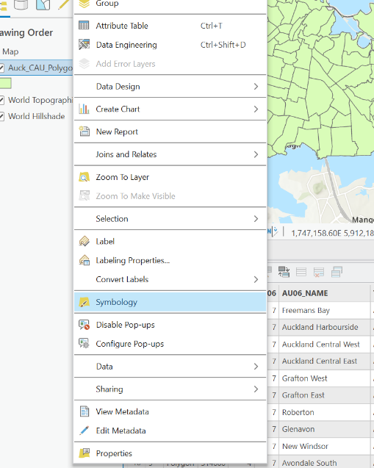
In the “Properties” tab in the Symbology window (right pane), left click on the coloured box next to “Symbol”.
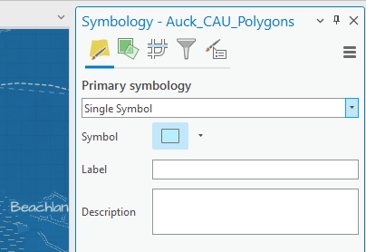
You can change the colour of the CAU outline and/or fill. Make your selections and click “Apply” at the bottom of the pane.
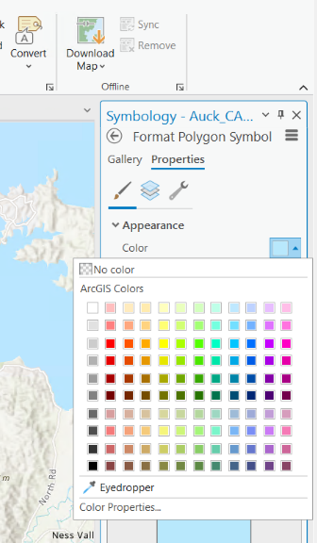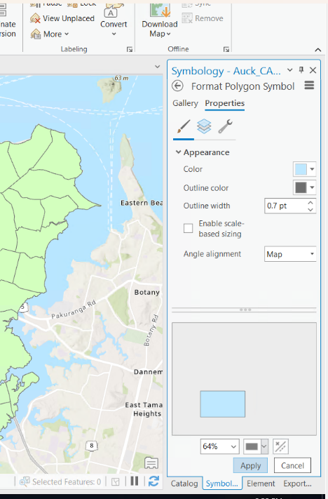

You can also change the colour Symbology directly from the Contents pane by right-clicking on the colour square under the layer’s name.
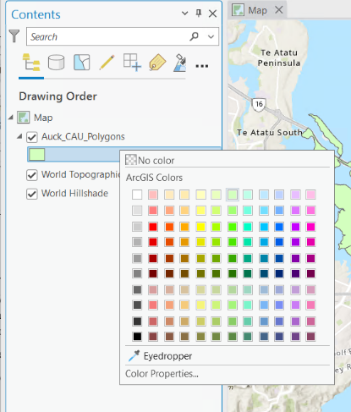

5. Display CAUs by colours depending on each CAU’s area size (km²)
Now, re-open the “Symbology” window by repeating the steps above. Click on the “Primary Symbology” image (leftmost symbol)
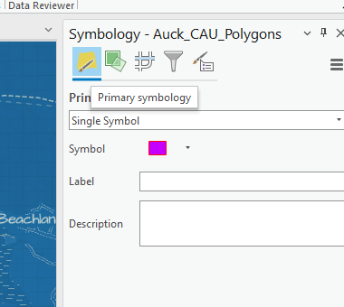.
Then, use the dropdown menu and click “Graduated Colors”.
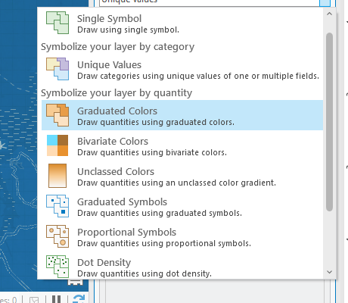
Click on the “Field” dropdown menu and change the field to “AreaKM”. You can assign the number of Classes (groups), the method for determining groups (e.g., Natural Breaks), and the colour scheme. Make your own choices!
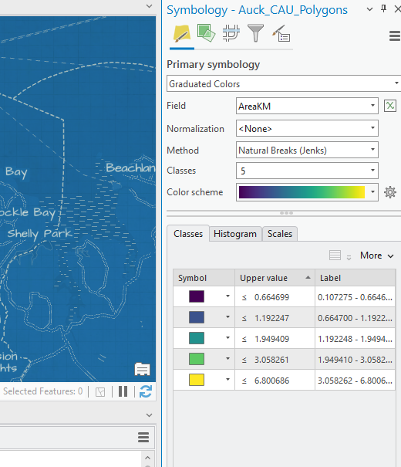
6. Switch to layout so we can make a map for output
When you are happy with your colour choices, change from data view to layout view by going to the “Insert” tab and selecting “New Layout”. Select your preferred size and orientation of your new layout.

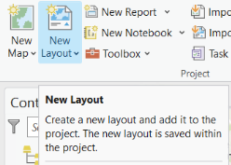

Select “Map Frame” to add your map. ‘Default Extent’ is NOT the best for viewing your map at an appropriate scale. Select the generated map scale option instead.
HINT: Make sure to click “Zoom to Layer” in the Map tab in order to get the best view of your map!
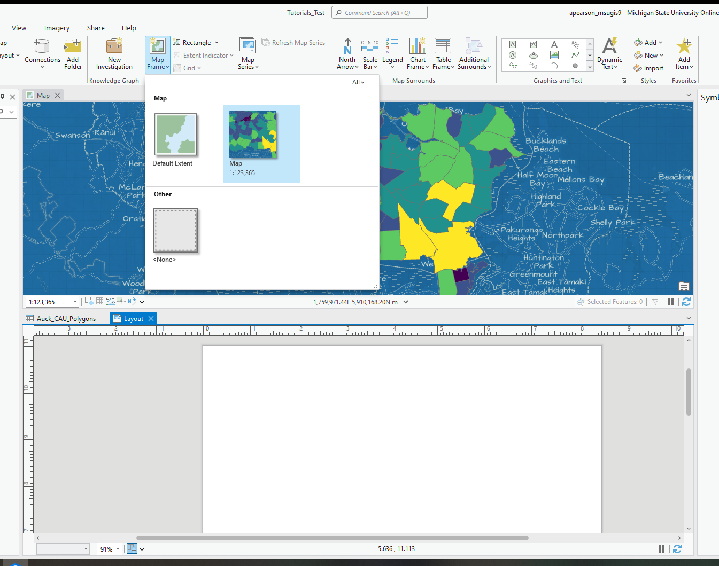
Use your mouse to draw the map frame on your layout pane, so that your map is completely visible. This can be a little tricky the first time.
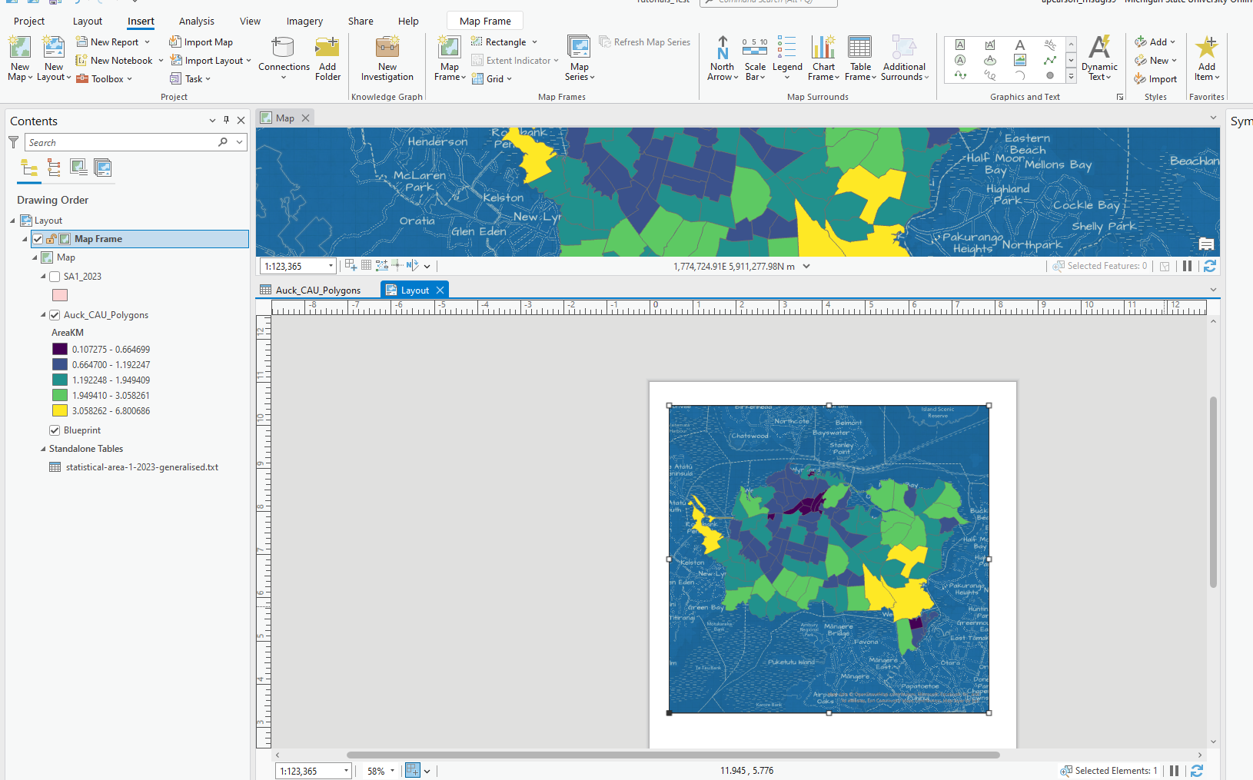
NOTE: The default is that AcrPro adds information about the basemap used – this may not be wanted for your final product. Often, it is easily edited when you have the image (jpeg or tiff) by cropping the image.

7. Add a title
Go to the “Insert” tab and select “Dynamic text” from the “Graphics and Text” pane. Select “Name (Map Frame)”.
Using your mouse, click and drag to draw your Title text box.
Now double click the “Text 1” box in the Contents pane. This will open the Element pane on the right. Here, you can edit the title – name the map something relevant.
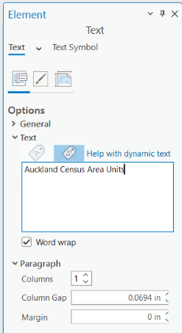
You can move the title to the location on the map that you desire by clicking and dragging the box. You can also change the font, size, and colour in the Element pane by clicking on the “Text Symbol” tab.

- Add a scale bar
Go back to “Insert” and select “Scale Bar”. There are metric options.
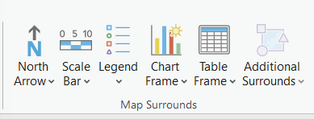
You can use the default settings or change the font, size, and colour options in the Element pane.
- Add a legend
Go back to “Insert” and select “Legend”. Start with option “A”. Use your mouse to draw it on your layout map. Now use the Element tab to make a solid background for the legend – use the Display image (third from left). Go to Background->Symbol. Then change it to solid white.
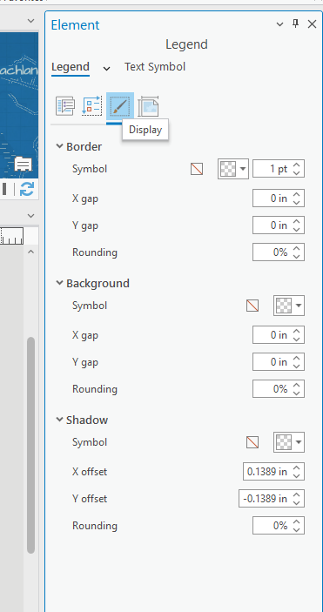
NOTE: THERE ARE LOTS OF CHOICES – but feel free to use defaults for now. Remember that there are many resources online for improving your map’s appearance, which you can refer to when you have time.
- Export a map (in jpeg or tiff format)!
When you are satisfied with your map, it is time to export your map as a jpeg or tiff file. This can be used to powerpoint presentations, on posters, in online publications, or in print.
Go to “Share” and select “Export layout”. Select the “GeoTIFF” icon— this will open the Export Layout pane on the right. Here, you can change the file type to a JPEG if you wish. The default is tiff (most journals require tiffs).
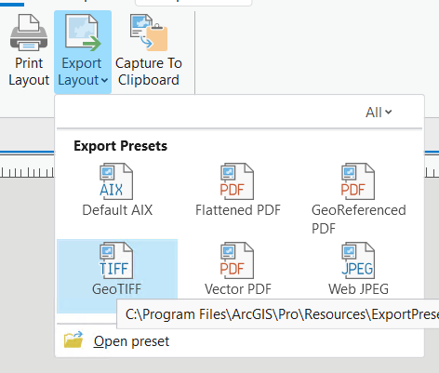
Choose a file name (eg: “Auck_CAUs_byArea.tiff”) and location. You can click the little yellow folder icon to browse to your working folder.
Notice options for dpi, compression, etc (some journals require a minimum of 300 dpi for publication, but the higher the dpi, the larger the file). You can also compress tiff files using other options – just ask me if interested. Don’t forget to click “Export” to export and save your map to your working folder.

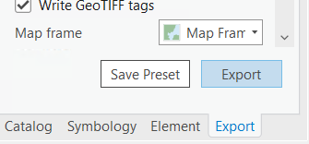

TUTORIAL 2
Geographic Techniques in Health
Geocoding and re-projecting
Task: To geocode case address data into a shapefile, and to transform a projection

Data needed:
- Stroke address file (StrokeAddresses.csv)
- Census Area Units for Auckland (Auck_CAU_Polygons.shp)

- Geocode Auckland addresses of cases of stroke (*this is not actual data)
Find the file StrokeAddresses.csv and add this data to ArcPRO.
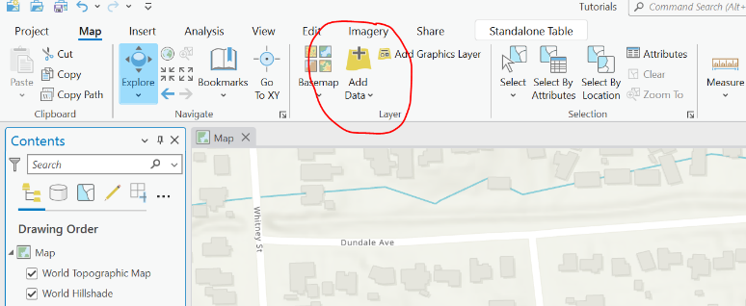
The csv file name will appear under the “Standalone Tables” section of the contents window. To geocode the addresses in the table, right click the name and press “Geocode Table”.
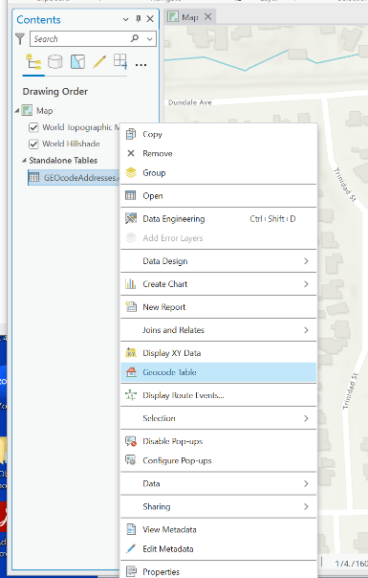
A Geocode Table window will appear on the right side, quickly review the steps and press Start (bottom right corner). For input locator select “ArcGIS World Geocoding Service”. Click Next.
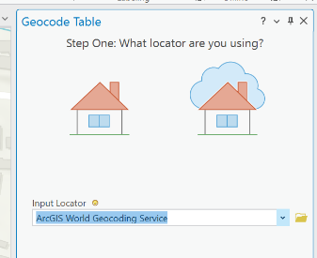
Now fill in the information regarding your table to look like this. Then Click Next.
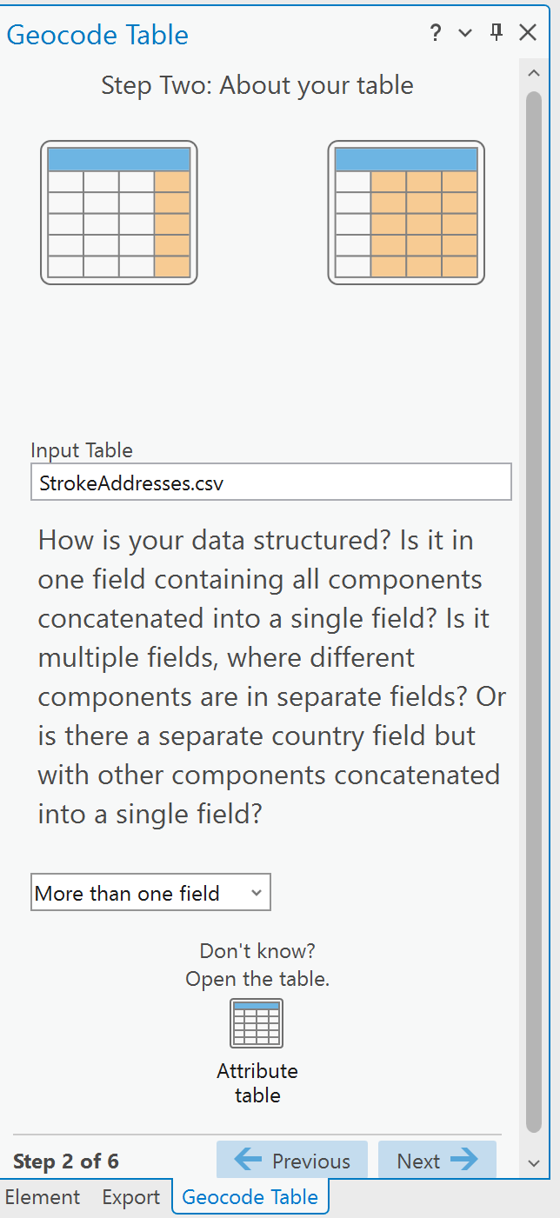
Next, you need to indicate which columns represents each part of the address. Based on the names of the columns in the csv file: Address = Street; City = Dependent_Locality; County = Locality; and Country = Country. Click Next. 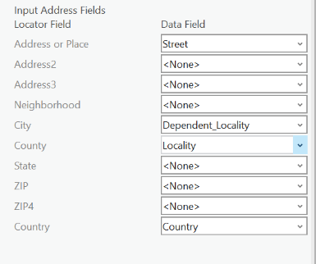
Select the output type, add output to map, and select how you want the spatial output to appear. We want point locations for each geocoded address, thus the input should look like this. Then, click Next.
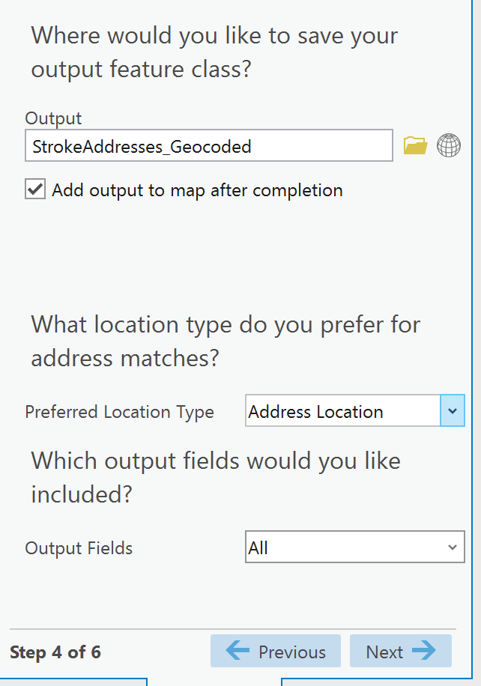
Now select the country you are geocoding addresses for from the list provided (New Zealand). Click Next.
Finally, our locations are limited to addresses so we will check “Address”. Click Finish. 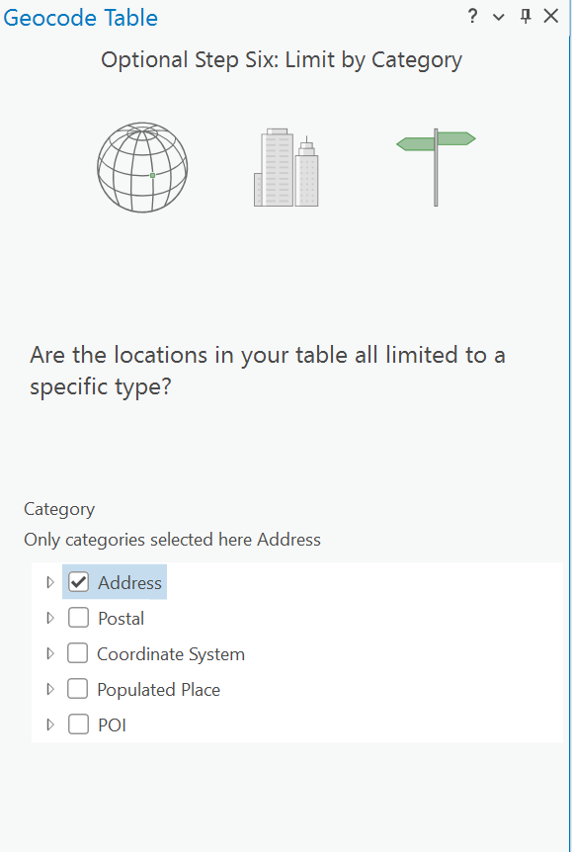
Note that geocoding consumes “credits”. You have to estimate the credits at the top of the Geocoding window before you can run this process. Credits will depend on license type, number of addresses to geocode, etc. Confirm everything looks appropriate, and then Click Run.

After running, a pop-up window will appear regarding match success rate. A tie means there are at least two choices in your spatial data that your address list can match against. It's up to you to go through and pick which one you want it to match against. For me, ties are a data quality test. More ties means less data integrity and accuracy.
If addresses are unmatched, you can then assess and geocode them manually, using programs like Google Earth.

We are going to skip this process for now. Click No.
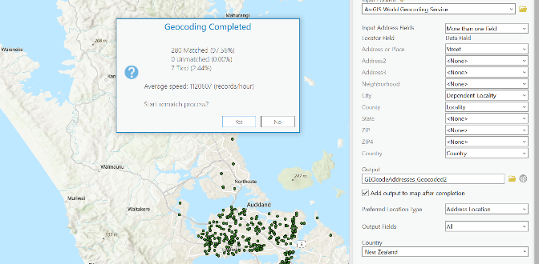
Not the program will offer to rematch addresses if desired to confirm appropriateness. You can accept the initial matching by selecting “auto apply.” At this point it is okay to close out the Geocode window.
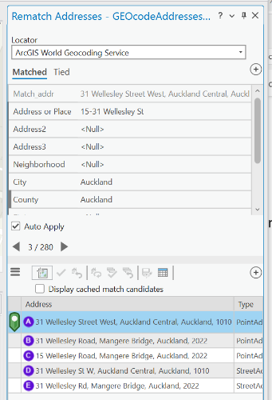
Finally, let’s download the new shapefile of geocoded addresses. To do so, right click on “StrokeAddresses_Geocoded” in the contents window (or whatever you named the new layer) and select Data Export features.
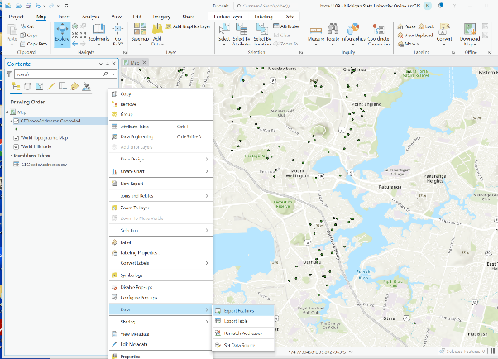
[***Always make sure that no points/lines/polygons/cells are selected before exporting, to confirm you can click the clear button on the top ribbon in the selection section]

TUTORIAL 2 – BONUS MATERIAL
Download existing spatial data, append tabular data
Task: To obtain shapefiles from StatsNZ, to append a dataset to the spatial data
Data:
- Age-standardised mortality rates by SA2 (ASM_Rate_bySA2.xls)
- SA2 geographic file from: https://datafinder.stats.govt.nz/

Download spatial data. Go to the above website. Find the appropriate file called “Statistical Area 2 2018 Clipped (generalised).” Click on the download button:
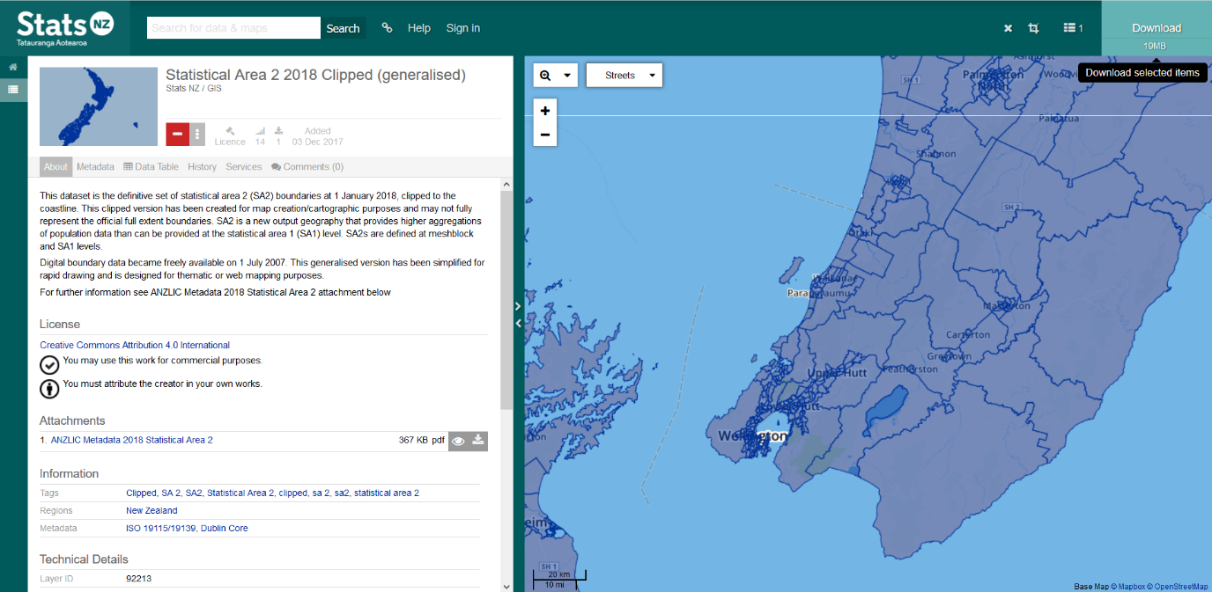
Accept terms and download. You have to provide some details including name and email address.
Put these files on your work location.
- Add the shapefile to a new session of ArcPro. Click the refresh button or simply close the existing program and open again. You do not need to save changes that were not already saved from the first half of this tutorial.
- Add the file called “ASM_Rate_bySA2.csv” to the session.

- We want to link the mortality data to our SA2 geographic data so that we can display mortality rates for northern areas of the North Island on a map. Highlight the SA2 shapefile name and right click.
Go to ‘Add join’. Input table = SA2 shapefile. Input field = “SA22018_V1” or similar name. Join Table = “ASM_Rate_bySA2”. Join field = “SA22018_V1”. Make sure Keep all input records is selected.
Click OK.

Go to the attribute table for the SA2 shapefile. Notice the last column is new.

- Practice your cartography skills from tutorial 1

Now you can make a map of these rates, using the symbology options – Quantities-ASM_Rate.

Select colours you like that reflect your message.

Add a title, scale bar and a legend.

Export this as a jpeg or tiff to your work location.

